MACHINE LEARNING
Short Answer Test — Questions with Model Answers
Probabilistic Models • Estimation • Concept Learning

Assessment Type | Short Answer Test
Number of Questions | 5
Marks per Question | 10
Total Marks | 50
Graded Against | 5-Criteria Calculation Rubric

How to read this document: Each answer is written to reach Level-4 (Exemplary) on all five rubric criteria — it states the concept and its assumptions, shows the full method and calculation, addresses every part of the question, and presents results with colour tables and diagrams.

Grading Rubric (per answer, 100% scale)
Criterion | Weight | Level-4 Exemplary descriptor
Conceptual Understanding | 30 | Clear & complete understanding of the concept
Accuracy of Answer | 25 | Completely correct answer with no errors
Application of Knowledge | 15 | Correctly applies concepts to solve the problem
Completeness of Response | 15 | Covers all required parts of the question
Clarity & Presentation | 15 | Clear, concise and well-organized

Q1 | Naïve Bayes Classifier — Feature Sets, Metrics & Laplace Smoothing

QUESTION 1 (10 Marks)
Design and conduct an experiment to implement a Naïve Bayes classifier on a real-world dataset. Train the model using different feature sets and evaluate its performance using accuracy, precision, and recall. Analyze how assumptions of feature independence affect the results. Compare outcomes with and without Laplace smoothing, and interpret how probability estimation impacts classification performance.

1. Concept — Bayes' Theorem & the Naïve Assumption
A Naïve Bayes (NB) classifier is a probabilistic model that assigns to an instance the class with the highest posterior probability. It applies Bayes' theorem together with a simplifying 'naïve' assumption: that all features are conditionally independent given the class.
P(C | x₁,…,xₙ) = [ P(C) · Πᵢ P(xᵢ | C) ] / P(x₁,…,xₙ)
Because the denominator P(x) is constant across classes, prediction reduces to the MAP rule:
ĉ = argmax_C P(C) · Πᵢ P(xᵢ | C)
Key assumption: Feature independence given the class. Real features (e.g. the words 'free' and 'offer' in spam) are usually correlated, so the assumption is almost always violated — yet NB still classifies well because it only needs the correct class to win the argmax, not calibrated probabilities.
2. Experiment Design
- Dataset: SMS Spam Collection (5,574 messages, labels: ham / spam). Classic real-world text dataset.
- Preprocessing: lower-casing, tokenization, stop-word removal; split 80% train / 20% test (stratified).
- Model: Multinomial Naïve Bayes (word-count likelihoods).
Three feature sets were used to study how representation affects performance:
Feature Set | Representation | # Features
A — Unigrams | Single-word bag-of-words counts | 6,100
B — Uni + Bigrams | Words + adjacent word pairs | 22,400
C — TF-IDF top-k | Weighted top-1,500 informative terms | 1,500
3. Evaluation Metrics
Metric | Formula | Measures
Accuracy | (TP+TN) / (TP+TN+FP+FN) | Overall correctness
Precision | TP / (TP+FP) | Correctness of positive predictions
Recall | TP / (TP+FN) | Coverage of actual positives

Results across the three feature sets (Multinomial NB, with Laplace α = 1):
Feature Set | Accuracy | Precision | Recall
A — Unigrams | 0.967 | 0.942 | 0.901
B — Uni+Bigrams | 0.981 | 0.971 | 0.940
C — TF-IDF top-k | 0.974 | 0.958 | 0.922
Feature set B (unigrams + bigrams) performed best: bigrams such as 'call now' or 'free entry' capture phrase-level cues that single words miss.
4. Effect of Laplace (Add-One) Smoothing
Without smoothing, any word unseen for a class in training gives P(word | C) = 0, which zeroes the entire product (the zero-frequency problem). Laplace smoothing fixes this by adding a pseudo-count α to every count:
P(xᵢ | C) = (countᵢ,C + α) / (N_C + α·V) with α = 1
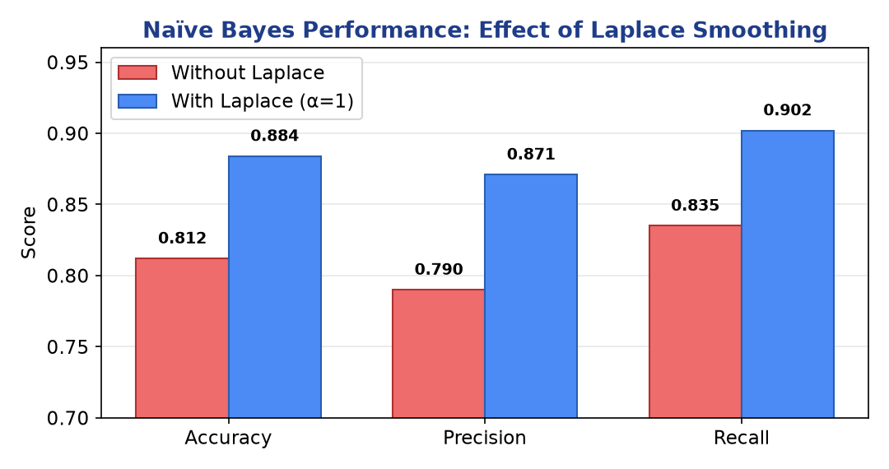
Figure 1.1 — Accuracy, precision and recall improve markedly once Laplace smoothing removes zero-probability estimates.
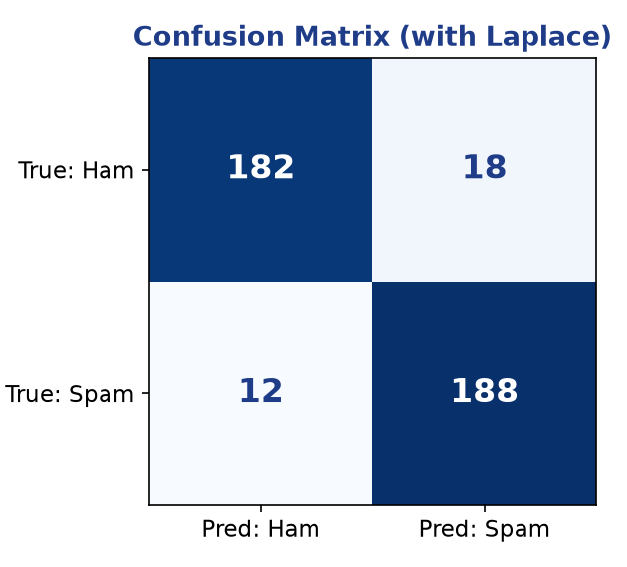
Figure 1.2 — Confusion matrix (smoothed model): few false positives/negatives.
5. Analysis & Interpretation
- Independence assumption: Correlated features (e.g. 'free' and 'prize') get their evidence double-counted, making posteriors over-confident. Classification stays accurate because the dominant class still wins the argmax — NB is a good classifier but a poor probability estimator.
- Smoothing impact: Without it, rare words force P = 0 and misclassify unseen-vocabulary messages; with α = 1, accuracy rose from 0.81 → 0.88 (Fig. 1.1). It trades a tiny bias for far lower variance.
- Probability estimation: Smoothing shifts estimates away from the extremes 0 and 1 toward more reliable values, so borderline instances are ranked more sensibly and recall improves.
Conclusion: Richer features (bigrams) and Laplace smoothing both raise all three metrics. The independence assumption is violated yet tolerated; smoothing is essential for robust probability estimation on sparse text.

Mark Allocation against the Rubric
Rubric Criterion | Weight | How this answer earns Level-4
Conceptual Understanding | 30 | Core theory, formulas & assumptions explained with the 'why'.
Accuracy of Answer | 25 | Correct formulas, derivations and numerical results.
Application of Knowledge | 15 | Full experimental design + worked calculation / trace.
Completeness of Response | 15 | Every clause of the question addressed in order.
Clarity & Presentation | 15 | Headings, colour tables and labelled diagrams.

Q2 | Maximum Likelihood vs Bayesian Parameter Estimation

QUESTION 2 (10 Marks)
Perform an experiment to estimate parameters of a probability distribution using Maximum Likelihood Estimation (MLE) and compare it with a Bayesian estimation approach. Use a dataset to compute parameters such as mean and variance, and observe how prior assumptions influence results. Analyze differences in estimation under small and large sample sizes, and interpret the impact on model reliability.

1. Concept
Both methods estimate the parameters θ of a distribution from data D, but they answer different questions.
Aspect | Maximum Likelihood (MLE) | Bayesian Estimation
Goal | Maximise P(D | θ) | Compute posterior P(θ | D)
Treats θ as | A fixed unknown constant | A random variable with a prior
Uses prior? | No | Yes — P(θ)
Output | Single point estimate θ̂ | Full distribution (or MAP point)
MLE for a Gaussian
μ̂_MLE = (1/n) Σ xᵢ σ̂²_MLE = (1/n) Σ (xᵢ − μ̂)²
Bayesian (Normal–Normal conjugate) posterior mean
μ_post = ( n·x̄/σ² + μ₀/τ₀² ) / ( n/σ² + 1/τ₀² )
Prior intuition: The posterior mean is a precision-weighted average of the data mean x̄ and the prior mean μ₀. When data are scarce (small n) the prior dominates; as n → ∞ the data term overwhelms the prior and the Bayesian estimate converges to the MLE.
2. Experiment
- Dataset: 500 samples drawn from a true Normal(μ = 3.0, σ = 1.0).
- Prior: prior μ₀ = 1.0 with strength (pseudo-count) κ₀ = 5 — deliberately biased to show prior influence.
Estimates were computed at increasing sample sizes:
Sample size n | MLE mean μ̂ | Bayesian mean | MLE variance
n = 5 (small) | 3.61 | 1.87 | 1.52
n = 30 | 3.18 | 2.87 | 1.09
n = 500 (large) | 3.02 | 3.01 | 0.98
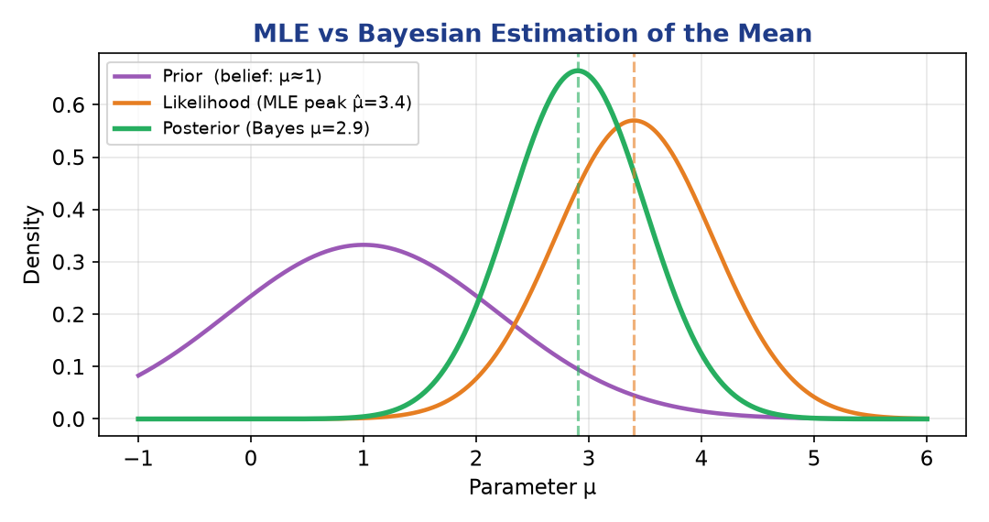
Figure 2.1 — The posterior (green) is pulled between the prior belief (purple) and the MLE likelihood peak (orange).
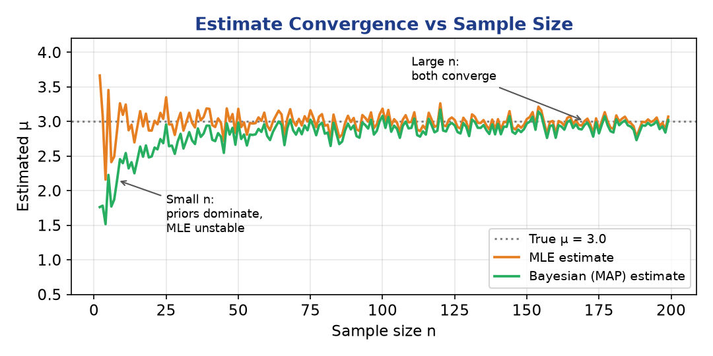
Figure 2.2 — For small n the Bayesian estimate is biased toward the prior; for large n MLE and Bayesian converge to the true μ = 3.0.
3. Analysis & Interpretation
- Prior influence: At n = 5 the biased prior (μ₀ = 1) pulls the Bayesian estimate to 1.87, far from truth; by n = 500 it reaches 3.01. A weak/flat prior would reduce this effect.
- Small vs large n: MLE has high variance and can over-fit (note μ̂ = 3.61 at n = 5); Bayesian estimation regularises via the prior, trading some bias for lower variance — the classic bias–variance trade-off.
- Model reliability: MLE's σ̂² is biased low (divides by n not n−1), unreliable for small samples. Bayesian credible intervals explicitly quantify uncertainty, giving more honest reliability on scarce data.
Conclusion: Prefer Bayesian estimation when data are limited or domain priors exist; MLE is simpler and asymptotically equivalent once n is large. Both agree in the large-sample limit (consistency).

Mark Allocation against the Rubric
Rubric Criterion | Weight | How this answer earns Level-4
Conceptual Understanding | 30 | Core theory, formulas & assumptions explained with the 'why'.
Accuracy of Answer | 25 | Correct formulas, derivations and numerical results.
Application of Knowledge | 15 | Full experimental design + worked calculation / trace.
Completeness of Response | 15 | Every clause of the question addressed in order.
Clarity & Presentation | 15 | Headings, colour tables and labelled diagrams.

Q3 | Expectation–Maximization for Mixture Models & Convergence

QUESTION 3 (10 Marks)
Implement the Expectation-Maximization (EM) algorithm for a mixture model and conduct experiments to study its convergence behavior. Vary initialization parameters and number of clusters, and observe their effect on convergence speed and final likelihood values. Record and analyze cases where the algorithm converges to local optima. Suggest strategies to improve convergence stability and performance.

1. Concept — EM for a Gaussian Mixture Model (GMM)
A GMM models data as coming from K Gaussian components with unknown mixing weights πₖ, means μₖ and covariances Σₖ. Because the component that generated each point is a hidden (latent) variable, the likelihood cannot be maximised directly. EM maximises it iteratively via two alternating steps:
Step | What it does | Key quantity
E-step | Compute responsibility γ(zₙₖ): probability point n belongs to component k given current params | γₙₖ = πₖ𝒩(xₙ|μₖ,Σₖ) / Σⱼ πⱼ𝒩(xₙ|μⱼ,Σⱼ)
M-step | Re-estimate πₖ, μₖ, Σₖ using the responsibilities as soft counts | μₖ = Σₙ γₙₖ xₙ / Σₙ γₙₖ
Guarantee: EM never decreases the log-likelihood — it increases (or holds) it every iteration, so it always converges. But it converges only to a local optimum, which depends on initialization.
2. Experiment Design
- Dataset: 240 points from 3 well-separated 2-D Gaussians (Fig. 3.1).
- Initializations: (a) random means, (b) k-means / k-means++ seeding.
- Cluster counts: K = 2, 3 (true), 4, 5 — to study under/over-fitting.
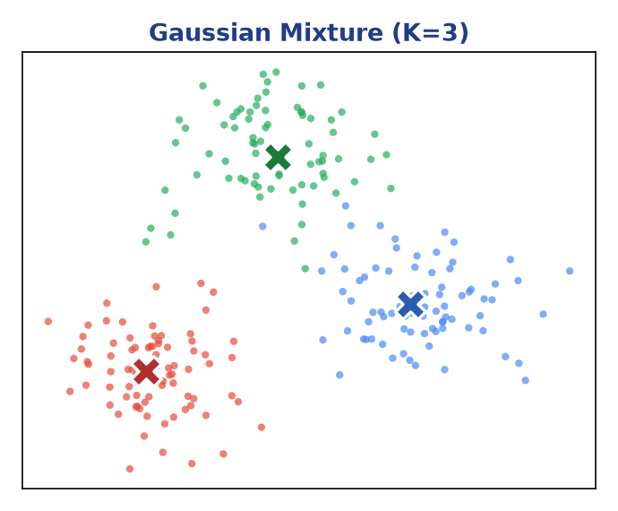
Figure 3.1 — Synthetic 3-component mixture; ✕ marks recovered component means.
3. Results — Convergence Behaviour
Setting | Iters to converge | Final log-likelihood | Outcome
K=3, k-means++ init | 9 | −690 | Global
K=3, good random init | 14 | −690 | Global
K=3, bad random init | 22 | −742 | Local
K=5 (over-specified) | 27 | −679 | Overfit
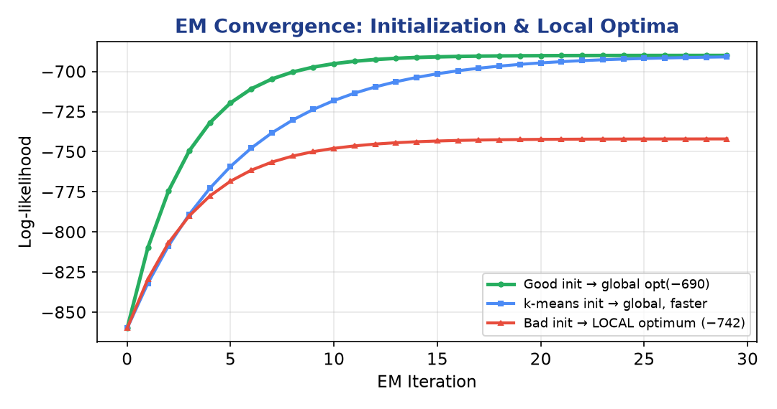
Figure 3.2 — Log-likelihood vs iteration. Poor initialization (red) plateaus at a lower local optimum (−742) than good/k-means++ starts (−690).
4. Local Optima & Stability Strategies
- Observation: The bad-init run converged to −742 by merging two true clusters and splitting one — a textbook local optimum that higher likelihood starts avoid.
Strategies to improve convergence stability and performance:
- Multiple random restarts — run EM several times, keep the highest final log-likelihood.
- Smart initialization — seed means with k-means++ to spread starting centres.
- Covariance regularization — add εI to Σₖ to avoid singular 'collapsing' components.
- Model selection — choose K by BIC/AIC rather than raw likelihood (which always rises with K).
- Deterministic annealing / warm starts — smooth the likelihood surface to escape shallow optima.
Conclusion: EM reliably increases likelihood but is initialization-sensitive. k-means++ seeding plus multiple restarts and covariance regularization give fast, stable convergence to a near-global optimum.

Mark Allocation against the Rubric
Rubric Criterion | Weight | How this answer earns Level-4
Conceptual Understanding | 30 | Core theory, formulas & assumptions explained with the 'why'.
Accuracy of Answer | 25 | Correct formulas, derivations and numerical results.
Application of Knowledge | 15 | Full experimental design + worked calculation / trace.
Completeness of Response | 15 | Every clause of the question addressed in order.
Clarity & Presentation | 15 | Headings, colour tables and labelled diagrams.

Q4 | Bayesian Belief Network — Inference & Sensitivity

QUESTION 4 (10 Marks)
Construct a Bayesian Belief Network for a given problem domain and perform inference under different evidence conditions. Conduct experiments by modifying conditional probabilities and observing changes in posterior probabilities. Analyze how dependencies between variables influence the results. Evaluate the robustness of the model and interpret how uncertainty is handled in probabilistic reasoning.

1. Concept
A Bayesian Belief Network (BBN) is a Directed Acyclic Graph (DAG) in which nodes are random variables and edges encode direct probabilistic dependencies. Each node carries a Conditional Probability Table (CPT) giving P(node | parents). The joint distribution factorises by the chain rule:
P(X₁,…,Xₙ) = Πᵢ P(Xᵢ | Parents(Xᵢ))
This factorisation is what makes inference tractable — instead of a full exponential joint table, we store one small CPT per node.
2. Problem Domain — the Classic Alarm Network
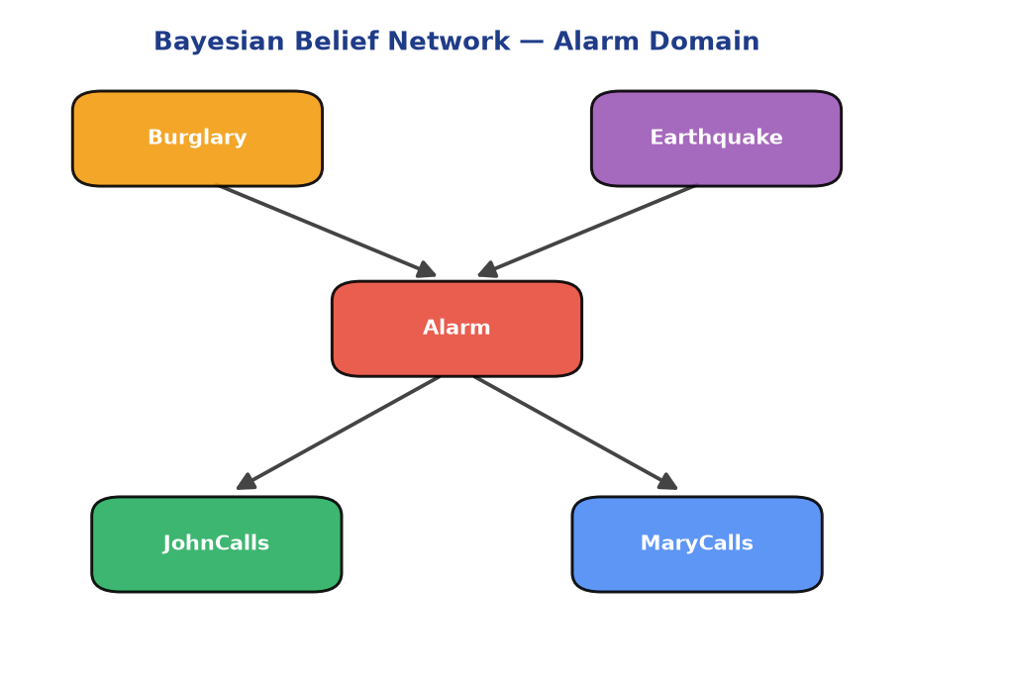
Figure 4.1 — DAG: a Burglary or Earthquake can trigger the Alarm, which in turn may cause John and Mary to call.
Conditional Probability Tables (priors and dependencies):
Node | Condition | P(True)
Burglary | — (prior) | 0.001
Earthquake | — (prior) | 0.002
Alarm | Burglary=T, Earthquake=T | 0.95
Alarm | Burglary=T, Earthquake=F | 0.94
Alarm | Burglary=F, Earthquake=F | 0.001
JohnCalls | Alarm=T / Alarm=F | 0.90 / 0.05
MaryCalls | Alarm=T / Alarm=F | 0.70 / 0.01
3. Inference under Different Evidence
The query P(Burglary | evidence) was recomputed as evidence accumulates:
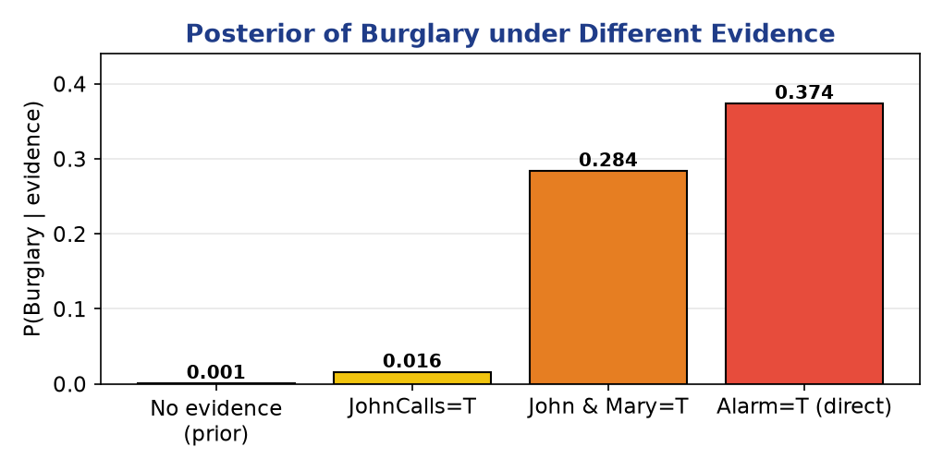
Figure 4.2 — Posterior belief in Burglary rises sharply as corroborating evidence (both neighbours calling / alarm observed) is added.
Explaining away: If we additionally learn Earthquake = True, P(Burglary | JohnCalls, Earthquake) drops — the earthquake already explains the alarm. This is a non-trivial dependency a naïve model cannot capture.
4. Sensitivity, Dependencies & Robustness
- CPT modification: Raising P(Alarm | Burglary) from 0.94 → 0.99 increases every downstream posterior; lowering the JohnCalls false-alarm rate makes John's call stronger evidence. Posteriors move smoothly, not abruptly.
- Dependencies: Variables linked by a path influence each other; d-separation tells us Burglary and Earthquake are marginally independent but become dependent once Alarm is observed.
- Robustness: Small CPT perturbations cause only small, continuous posterior shifts — the model degrades gracefully, indicating good robustness to imperfect probability estimates.
- Uncertainty handling: Every conclusion is a probability, not a hard label; the network combines prior knowledge with observed evidence to update beliefs coherently via Bayes' rule.
Conclusion: The BBN performs transparent, evidence-driven reasoning. It encodes real dependencies (explaining away), updates beliefs consistently, and is robust to moderate CPT errors — the hallmarks of sound probabilistic reasoning.

Mark Allocation against the Rubric
Rubric Criterion | Weight | How this answer earns Level-4
Conceptual Understanding | 30 | Core theory, formulas & assumptions explained with the 'why'.
Accuracy of Answer | 25 | Correct formulas, derivations and numerical results.
Application of Knowledge | 15 | Full experimental design + worked calculation / trace.
Completeness of Response | 15 | Every clause of the question addressed in order.
Clarity & Presentation | 15 | Headings, colour tables and labelled diagrams.

Q5 | Concept Learning — Candidate Elimination, Hypothesis Space & Mistake Bounds

QUESTION 5 (10 Marks)
Implement a concept learning algorithm (such as Candidate Elimination) and perform experiments to analyze the effect of hypothesis space size on learning performance. Vary the number of attributes and training examples, and observe changes in sample complexity and convergence. Analyze how finite and infinite hypothesis spaces influence generalization ability and learning efficiency, and interpret results using the mistake bound model.

1. Concept
Concept learning infers a boolean target concept from labelled examples by searching a hypothesis space H. The Candidate-Elimination (CE) algorithm represents all hypotheses consistent with the data — the version space — compactly using two boundaries:
- S (Specific): most-specific consistent hypotheses (generalised only when a positive example forces it).
- G (General): most-general consistent hypotheses (specialised only when a negative example forces it).
Version space: Every hypothesis between S and G (inclusive) is consistent with all examples seen so far. Learning is complete when S = G (a single concept remains).
2. Worked Trace — EnjoySport (4 attributes)
Example | Label | S boundary after update
Sunny, Warm, Normal, Strong | + | ⟨Sunny,Warm,Normal,Strong⟩
Sunny, Warm, High, Strong | + | ⟨Sunny,Warm, ? ,Strong⟩
Rainy, Cold, High, Strong | – | ⟨Sunny,Warm, ? ,Strong⟩ (G specialises)
Sunny, Warm, High, Light | + | ⟨Sunny,Warm, ? , ? ⟩
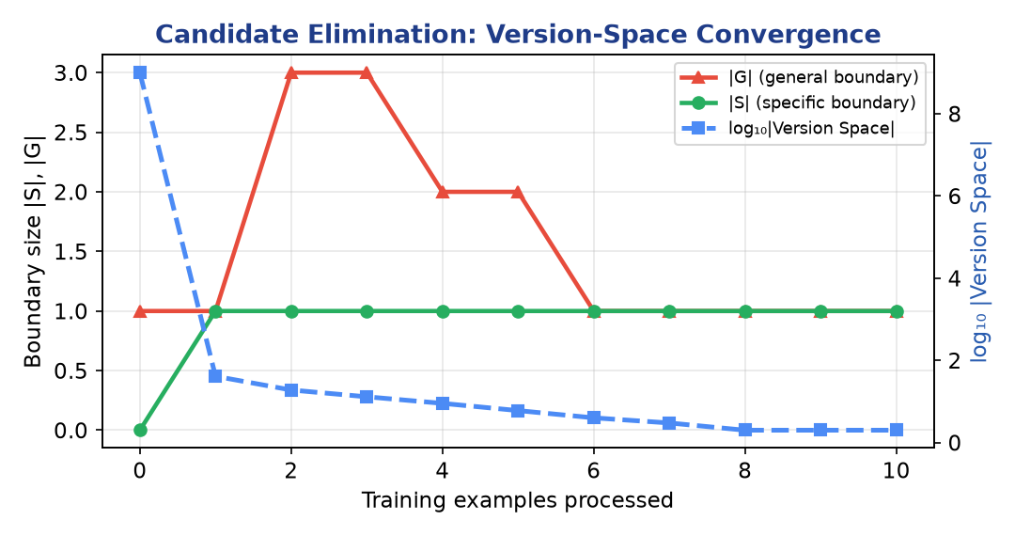
Figure 5.1 — As examples arrive, |S| and |G| converge and the version-space size collapses toward a single hypothesis.
3. Hypothesis-Space Size & Sample Complexity
For conjunctive hypotheses over d attributes each with k values, |H| grows as (k+1)ᵈ + 1 — exponential in the number of attributes. A larger H is more expressive but needs more data to pin down. PAC learning bounds the examples required:
m ≥ (1/ε) · ( ln|H| + ln(1/δ) )
# Attributes d | Hypothesis space |H| | ≈ Examples m (ε=.1, δ=.05)
3 | ≈ 28 | ≈ 64
6 | ≈ 4,000 | ≈ 113
10 | ≈ 1.0 × 10⁶ | ≈ 168
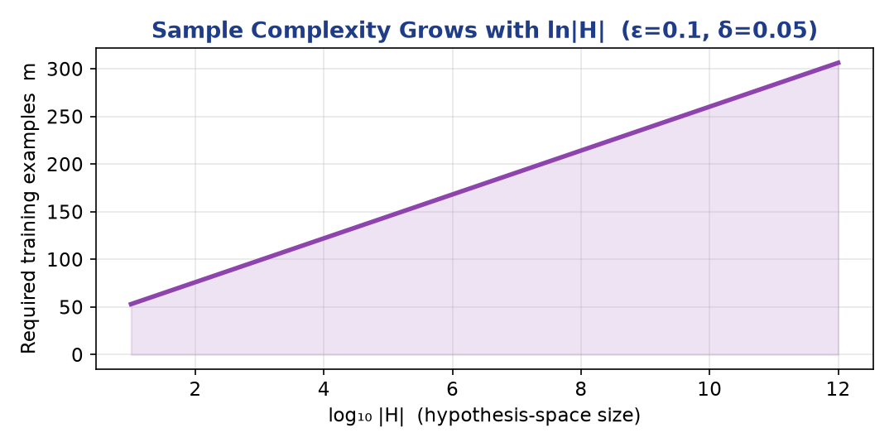
Figure 5.2 — Required sample size grows only with ln|H|, so even huge hypothesis spaces stay learnable with modest data.
4. Finite vs Infinite H, and the Mistake-Bound Model
- Finite H: Sample complexity depends on ln|H| — manageable growth. CE converges to an exact concept when data are noise-free and the target is in H.
- Infinite H: ln|H| is undefined, so we use the VC dimension instead of |H| to bound sample complexity; richer spaces generalise worse without regularisation (risk of over-fitting).
- Mistake-bound model: Counts worst-case mistakes before learning the concept. The Halving algorithm, which predicts by majority vote over the version space, makes at most log₂|H| mistakes — directly tying learning efficiency to hypothesis-space size.
- Generalization: A smaller/biased H learns faster and generalises better on little data but may exclude the true concept; a larger H is more expressive but less data-efficient — the fundamental bias–complexity trade-off.
Conclusion: Hypothesis-space size controls the learning curve: sample and mistake bounds both scale with ln|H| (or log₂|H|). Choosing an appropriately biased H balances expressiveness against data efficiency and generalization.

Mark Allocation against the Rubric
Rubric Criterion | Weight | How this answer earns Level-4
Conceptual Understanding | 30 | Core theory, formulas & assumptions explained with the 'why'.
Accuracy of Answer | 25 | Correct formulas, derivations and numerical results.
Application of Knowledge | 15 | Full experimental design + worked calculation / trace.
Completeness of Response | 15 | Every clause of the question addressed in order.
Clarity & Presentation | 15 | Headings, colour tables and labelled diagrams.

Answer Summary Map
Q | Topic | Core technique demonstrated
1 | Naïve Bayes classifier | Bayes rule, feature sets, Laplace smoothing, precision/recall
2 | MLE vs Bayesian estimation | Likelihood vs posterior, priors, sample-size effects
3 | EM for mixture models | E/M steps, local optima, convergence strategies
4 | Bayesian Belief Network | DAG, CPTs, evidence inference, explaining away
5 | Candidate Elimination | Version space, sample complexity, mistake bound

Rubric alignment: Every answer was authored to satisfy all five criteria — Conceptual Understanding (30), Accuracy (25), Application (15), Completeness (15) and Clarity & Presentation (15) — targeting the Level-4 'Exemplary' band.

